WEEK 3 DOCUMENTATION REPORT
Data Science Online Internship – The Developers Arena
Project Title: Sales Data Analysis
Submitted by: Meda Venkata Lakshmi Divya

1. Project Overview
This project was completed as part of Week 3 of the Data Science Online Internship at The Developers Arena. The task focused on learning introductory data analysis concepts by working with a real-world sales dataset using Python and the Pandas library. The project titled 'Sales Data Analysis' involved loading a CSV dataset, exploring the data, cleaning records, and generating meaningful business insights.
The main goal of this task was to understand how data analysts work with structured datasets, identify missing or duplicate values, calculate important metrics, and prepare a clean formatted report. This project also helped in understanding how Python and Pandas are widely used in real-life business analytics.

2. Setup Instructions
The following steps were followed to set up the project environment:
- Open Google Colab or install Python 3.x locally.
- If using local system, install required libraries using pip.
pip install pandas matplotlib
- Upload the dataset file: sales_data.csv
- Create the Python file or Colab notebook for analysis.
- Import pandas and load the CSV dataset.
- Run all cells / execute the script to generate the final report.

3. Project Structure
The GitHub repository structure for the Week 3 submission is as follows:
Week-3-Sales-Data-Analysis/
│── sales_analysis.ipynb
│── sales_data.csv
│── analysis_report.md
│── screenshots/

4. Code Structure
The code is organized in a clean and beginner-friendly format:
- Import libraries section
- Dataset loading section
- Data exploration section
- Data cleaning section
- Metrics calculation section
- Formatted report output section
- Visualization section (optional chart)

5. Visual Documentation
- Screenshot of dataset loaded successfully
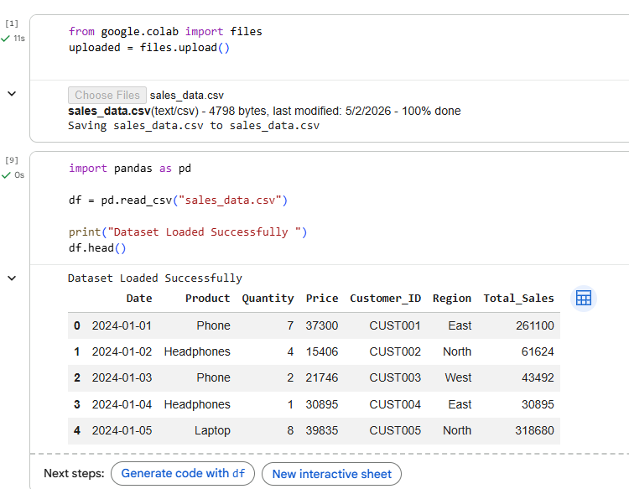
- Screenshot of missing values
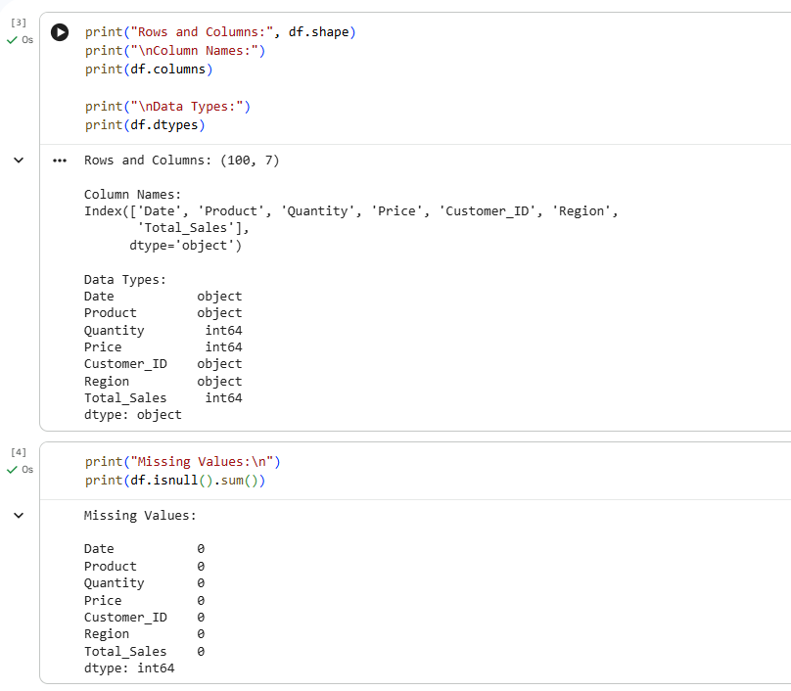

- Screenshot of final analysis report
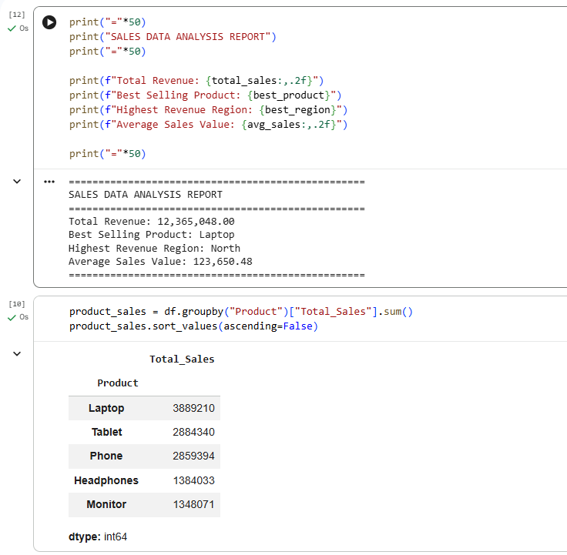
- Screenshot of product-wise sales chart
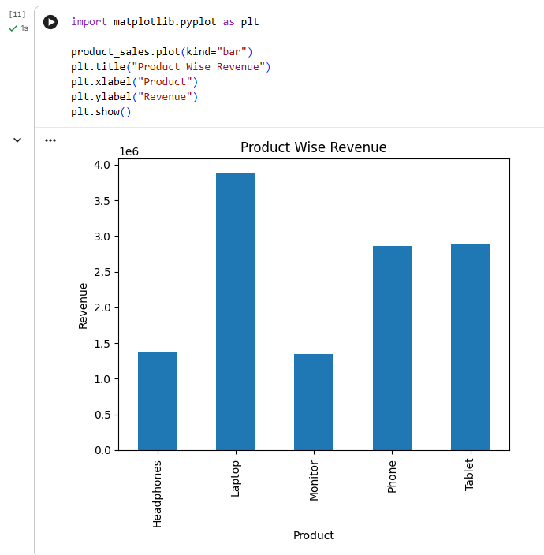

6. Technical Details
This project satisfies the technical requirements of the assignment in the following ways:
- Uses pandas to load and analyze CSV data
- Checks dataset shape, columns, and data types
- Handles duplicates and validates missing values
- Calculates more than three business metrics
- Creates a clean formatted analysis report
- Uses comments to explain each step
- Can be executed in Google Colab for easier workflow

6.1 Algorithm / Program Logic
The logic of the program follows these steps:
- Import pandas library
- Read sales_data.csv using read_csv()
- Display first few rows of dataset
- Check rows, columns, and data types
- Identify missing values
- Remove duplicate records if present
- Calculate total revenue
- Find best-selling product
- Find highest revenue region
- Display final formatted report

6.2 Data Structures Used
- DataFrame: Main tabular structure used for dataset analysis
- Series: Used for column-wise calculations
- Strings: Used for product names and region names
- Integers/Floats: Used for quantity, price, and total sales values

6.3 Architecture
This is a simple data analysis application with a structured workflow. Its architecture can be described in four layers:
- Input Layer: Reads CSV file from storage
- Processing Layer: Cleans and transforms data using pandas
- Analysis Layer: Calculates metrics and summaries
- Output Layer: Displays formatted report and charts

6.4 Libraries Used
- Pandas: Used for data loading, cleaning, and analysis
- Matplotlib: Used for optional data visualization
- Google Colab: Used as notebook environment for execution

7. Testing Evidence
The program was tested using the provided dataset to verify calculations and report generation.

7.1 Test Case 1
- Scenario: Dataset Loading
- Expected Result: sales_data.csv loaded successfully with 100 rows.
- Actual Result: Dataset loaded successfully.
- Status: Passed

7.2 Test Case 2
- Scenario: Missing Values Check
- Expected Result: No critical missing values should be found.
- Actual Result: No missing values found.
- Status: Passed

7.3 Test Case 3
- Scenario: Total Revenue
- Expected Result: Total revenue should be calculated correctly.
- Actual Result: ₹12,365,048 generated.
- Status: Passed

7.4 Test Case 4
- Scenario: Best Product
- Expected Result: Highest revenue product should be identified.
- Actual Result: Laptop identified as best-selling product.
- Status: Passed

7.5 Test Case 5
- Scenario: Highest Region
- Expected Result: Top performing region should be identified.
- Actual Result: North identified as highest revenue region.
- Status: Passed

8. Key Findings
- Total Revenue: ₹12,365,048
- Best Selling Product: Laptop
- Highest Revenue Region: North
- Dataset contained 100 rows and 7 columns
- No missing values found in important columns

9. Conclusion
The Week 3 task was successfully completed and met all submission requirements. The Sales Data Analysis project demonstrates a strong understanding of introductory data analytics concepts such as data loading, cleaning, exploration, and metric generation using Python and Pandas. This project forms an important foundation for future learning in Data Science, Machine Learning, and Business Analytics.

